

UNIVERSITY OF ENGINEERING & TECHNOLOGY
Department of Computer Engineering

ECAT EXAM APPLICATION
Dual Portal System — Design, Implementation & Analysis

Submitted by: Nazish Saghir
Registration: 2026(S)-CYS-21
Course: CMPE-112L — Fundamentals of Programming
Assignment: Complex Engineering Activity (CEA)
Instructor: Hafiz Muhammad Mubashar
Submission: 6 June 2026

ABSTRACT

This report documents the design and implementation of an ECAT Exam Application developed as part of the Complex Engineering Activity for the course CMPE-112L at the University of Engineering and Technology, Lahore. The application operates as a dual-portal, console-based system written entirely in Python, offering separate credential-protected entry points for administrative staff and registered students.
The Admin Portal enables the examination team to manage the question bank in real time — adding, deleting, and inspecting multiple-choice questions — while maintaining a live record of all student attempts with both summary and per-question granularity. The Student Portal presents a timed, structured examination experience with automatic submission, a negative marking scheme, and an instant result alongside a full answer review.
The system makes deliberate use of the fundamental Python constructs taught throughout CMPE-112L: variables, constants, conditional logic, iteration, functions, lists, and dictionaries. All persistent state is maintained in memory using Python lists and dictionaries for the duration of the program run. The report analyses the problem, walks through the architectural decisions, explains the data model, and maps each feature to the language concepts that underpin it.

1. INTRODUCTION

Standardised entrance examinations play a central role in Pakistan's engineering admissions landscape. The Engineering College Admission Test — universally known as ECAT — is the gateway through which thousands of aspiring students seek admission to programmes in mathematics, physics, chemistry, and computer science every year. Administering such an examination, even at a simulated or practice level, demands a reliable system that treats the two parties involved — the examining body and the candidate — with equal precision.
The motivation for this project stems directly from the pedagogical goals of CMPE-112L. Rather than demonstrating individual language features in isolation, a Complex Engineering Activity demands that students weave those features together into something coherent and purposeful. An examination application is an ideal vehicle: it is conceptually familiar, functionally rich, and yet compact enough to be realised within the constraints of a first-semester programming course.
This document presents the complete lifecycle of the application — from the initial problem statement through design decisions, data modelling, feature implementation, and a reflection on the Python concepts employed. Each section is intended to be read both as technical documentation and as a demonstration that the author has moved beyond mechanical syntax acquisition toward genuine, structured problem-solving.

1.1 Scope and Objectives

The scope of the application is deliberately focused. It does not attempt to replicate a full-scale online examination platform; instead, it addresses the core functional requirements set out in the project brief: a dual-login architecture, a dynamic question bank, a structured examination session with negative marking, and post-examination analytics for both the individual student and the examining body as a whole.
The primary objective is correctness — every feature must behave exactly as specified. The secondary objective is clarity: the code should read as a thoughtful solution, not a collection of ad-hoc procedures. The tertiary objective is coverage: every Python concept encountered in CMPE-112L must appear naturally in the code, justified by the problem rather than inserted for its own sake.

2. PROBLEM STATEMENT

The task is to design and implement a Python-based ECAT Exam Application that provides two separate, credential-protected portals. Portal 1 is reserved for the ECAT administrative team and must support full management of the question bank alongside comprehensive access to student results. Portal 2 is reserved for registered students and must guide them through a structured examination before presenting their result and an answer-by-answer review.

2.1 Core Requirements

The application must present a minimum of ten multiple-choice questions, each offering four labelled options. A student may answer any question by entering the corresponding letter, skip it by entering S, or terminate the session early by typing SUBMIT; if all questions are answered in sequence the exam concludes automatically.
The marking scheme is non-trivial and penalises guessing: a correct answer awards four marks, an incorrect answer deducts one mark, and a skipped question carries no penalty. Upon completion the student receives a score, a percentage, a grade classification, and a full review showing the correctness of every response.
From the administrative side, the system must let an authorised user view the complete question bank, add new questions, remove existing ones, inspect aggregate statistics about the bank, browse a summary table of all student attempts, drill into any individual attempt for a question-level breakdown, and examine class-wide statistics including highest and lowest scores, the class average, and a grade distribution. All data is to be held in memory using Python lists and dictionaries; no file I/O or database is required.

2.2 Security Constraints

Both portals enforce a three-attempt lockout. A user who fails to provide the correct credentials three consecutive times is denied further access for that session, preventing brute-force login attempts within the running application. The Admin Portal is keyed to the username ecat_admin and the password ecat@2024; the Student Portal accepts the shared credential student / student123, after which the individual student's full name and roll number are captured to personalise the result record.

3. SYSTEM DESIGN

The application follows a procedural, function-centric design. There are no classes; the state is held in two module-level data structures and all behaviour is encapsulated in seventeen named functions, each with a single, well-defined responsibility. This approach keeps the codebase approachable for a first-semester audience while still demonstrating the principle of separation of concerns.

3.1 Dual Portal Architecture

The application's entry point is a main loop that presents three choices: Admin Portal, Student Portal, or Exit. This top-level dispatcher ensures that the two portals never interfere with one another. Each portal is driven by its own inner menu loop, which persists until the authenticated user explicitly chooses to log out.
The Admin Portal exposes eight menu options, each mapping to a dedicated function. The Student Portal exposes three: start the exam, review the rules, or log out. The separation is not merely cosmetic — the admin functions read from and write to the global questions list and the global all_results list, while the student functions interact only with local variables and append a single record to all_results upon exam submission
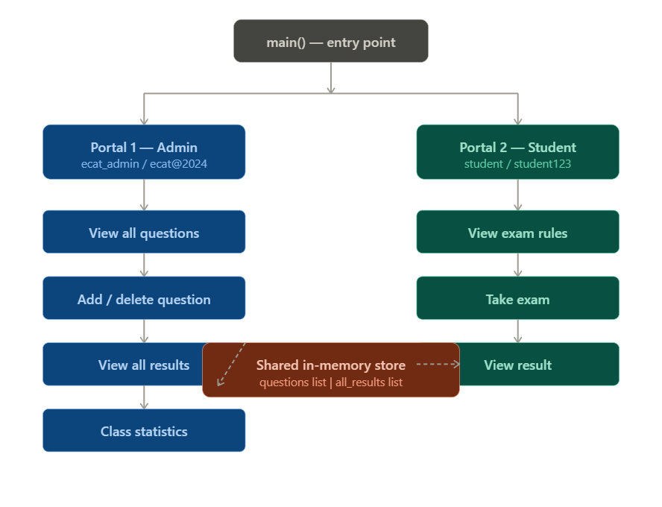
Figure 2 — Dual portal architecture: entry point, Admin Portal, Student Portal, and shared in-memory data store
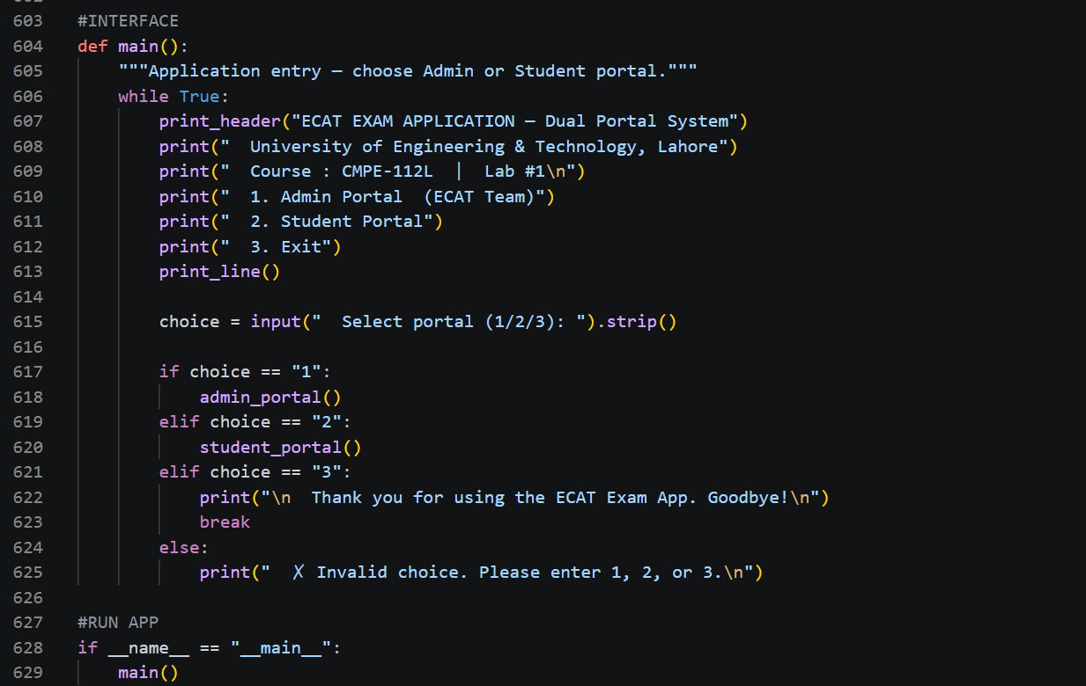

Figure 3 — The main() function: the top-level while loop that dispatches between Admin Portal, Student Portal, and Exit

3.2 Control Flow

Login is the gateway to both portals. The login functions implement a bounded while loop that counts failed attempts and exits when either the correct credentials are supplied or the attempt ceiling is reached. On success the admin loop immediately enters its menu; student login additionally prompts for a full name and roll number, which are threaded through the exam and result functions so that every record is uniquely attributed.
The exam itself is a for loop that walks the questions list from index zero to its end. Within each iteration an inner while loop handles the input-validation cycle, enforcing that only A, B, C, D, S, or SUBMIT are accepted. An early SUBMIT breaks out of the for loop after marking all unvisited questions as skipped, preserving the integrity of the scoring calculation regardless of when the student chose to exit.

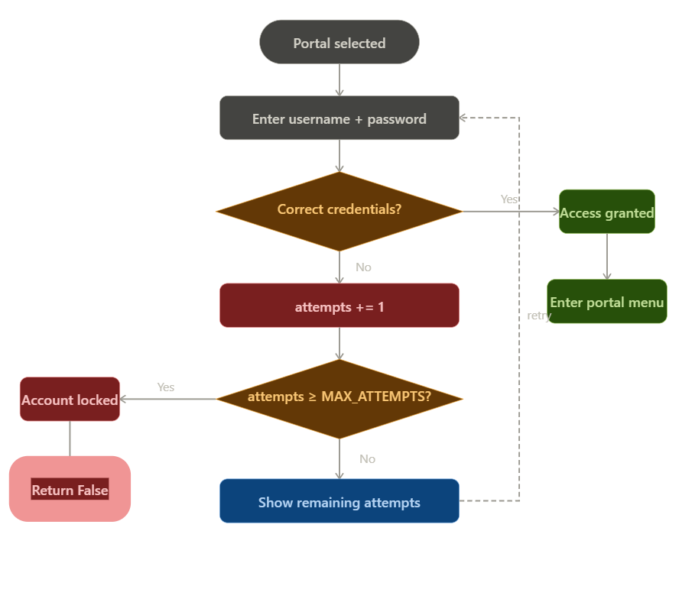
Figure 4 — Login flowchart: credential validation loop, attempt counter, lockout path, and access-granted branch

3.3 User Experience Considerations

The console interface uses uniform formatting helpers — print_header for section titles, print_line for dividers, and a brief time.sleep pause after login — to give the session a sense of rhythm and readability. Every invalid input triggers an immediate, specific error message rather than a silent retry or a generic failure, so the user always knows exactly what is expected. Menus are numbered and the prompt always restates the valid range, reducing cognitive load for students who may be sitting a practice examination under pressure.

4. DATA MODEL

The application manages three principal data structures. Two are module-level and persist for the entire session; one is local and exists only for the duration of a single examination attempt.

4.1 The Question Bank

The questions variable is a list of dictionaries. Each dictionary represents one multiple-choice question and carries five keys: id (an integer uniquely identifying the question), subject (a string categorising the question by discipline), question (the question text), choices (a nested dictionary mapping each of the four letter keys to its display text), and answer (the letter key of the correct response).
The application is seeded with twelve questions spanning Mathematics, Physics, Chemistry, and Computer Science, exceeding the minimum of ten required by the specification. This built-in bank demonstrates that the design works at realistic scale from the first run, without requiring the admin to populate the bank manually before the application can be used. During a session the admin may append to this list via admin_add_question or remove an entry via admin_delete_question; both operations take effect immediately and are reflected in any exam started after the change.

A representative entry from the question bank is structured as follows:

questions[0] = {
"id" : 1,
"subject" : "Mathematics",
"question": "What is the value of log2(8)?",
"choices" : { "A": "2", "B": "3", "C": "4", "D": "6" },
"answer" : "B"
}

Figure 1 — Structure of a single question dictionary in the in-memory question bank

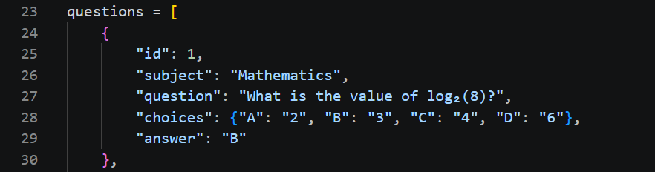
Figure 5 — The first question dictionary as it appears in the source file, showing all five keys: id, subject, question, choices, and answer

4.2 The Results Register

The all_results variable is a list that accumulates one dictionary per completed examination attempt. Each result record stores the student's name and roll number, the raw score, the maximum possible score, the counts of correct, wrong, and skipped responses, the computed percentage, the grade classification, a formatted date-time string, and the complete answers dictionary for that attempt.
Retaining the answers dictionary inside the result record is an important design choice: it allows the admin to reconstruct a full per-question review for any past attempt at any point in the session without requiring the exam to be re-taken. The admin_view_detailed_result function exploits this by iterating the stored answers alongside the current questions list, cross-referencing each stored answer against the stored correct answer to produce the CORRECT, WRONG, or SKIPPED verdict for each question.

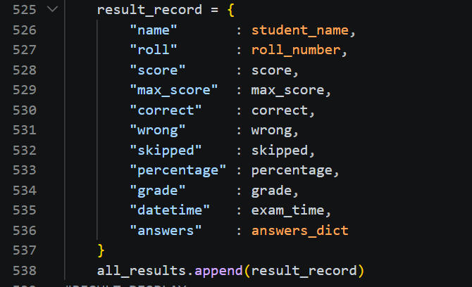
Figure 6 — The result_record dictionary showing all stored fields: name, roll, score, correct, wrong, skipped, percentage, grade, datetime, and embedded answers dict

4.3 The Answers Dictionary

During an active exam, the conduct_exam function builds a local answers dictionary that maps each question index to the student's response. Indices for questions that were skipped — either explicitly or because the student submitted early — are mapped to the sentinel string S. This design means that the calculate_score function receives a complete dictionary regardless of how the exam ended, and can apply the marking scheme uniformly without any special-case logic for early termination.

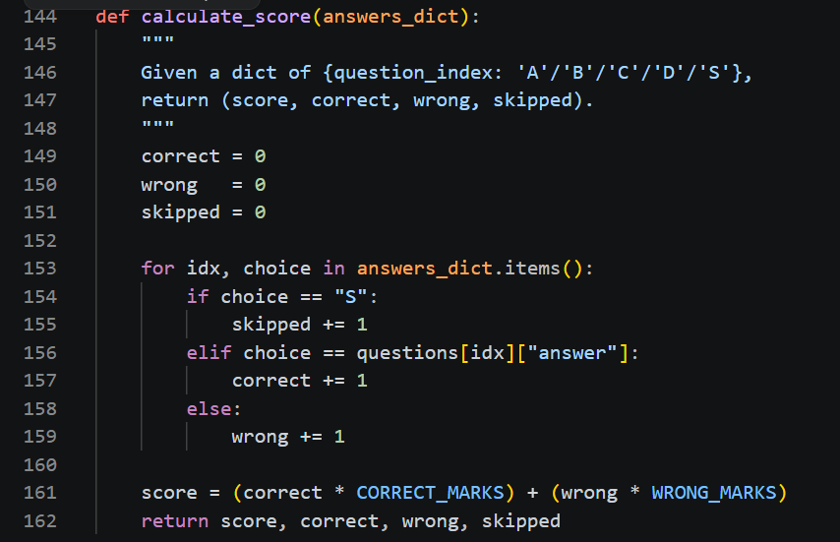

5. FEATURE IMPLEMENTATION

This section walks through each feature of the application in the order a user would encounter it, explaining not just what each function does but why it was implemented the way it was.

5.1 Authentication and Lockout

Both admin_login and student_login share the same structural template: a while loop bounded by a MAX_ATTEMPTS constant set to three. On each iteration the function prompts for credentials, compares them against hardcoded values, and either grants access or decrements the remaining attempt count. Once the count reaches zero the function returns a failure signal — False for the admin, a three-element tuple of (False, empty string, empty string) for the student — and the calling portal returns immediately without displaying its menu.
The student login diverges from the admin login in one important respect: it collects the student's full name and roll number after the credentials are verified. This deferral is intentional — there is no point asking for personal information from someone who cannot authenticate. The values are returned alongside the success flag so that the student portal can thread them into both the exam session and the result record.

5.2 Question Bank Management

The admin_view_all_questions function iterates the questions list with enumerate, printing each question's index, subject, text, choices, and correct answer. The correct answer is highlighted by a tick character placed beside the appropriate option, making it immediately legible without requiring the admin to decode letter codes.
Adding a question is a guided input sequence that collects each field in turn — subject, question text, four choice texts, and the correct letter — before assembling and appending a new dictionary. The function validates that the correct-answer field contains only one of the four valid letters before accepting the entry, and derives the new question's id automatically from the current maximum id in the list. Deletion is handled by prompting for a displayed number, converting it to a zero-based index, and calling list.pop, which removes the entry in-place without leaving a gap in the list.

5.3 The Examination Session

The conduct_exam function is the heart of the Student Portal. It iterates the questions list using a for loop driven by range(len(questions)), which gives access to both the integer index and the question dictionary at each step. The index is essential because it serves as the key under which the student's response is stored in the answers dictionary, allowing the result functions to align answers with questions by position.
Each question is presented with its subject tag, its text, and its four choices. The inner while True loop then accepts input until a valid token is received. The .strip() and .upper() string methods are applied to every input before comparison, silently correcting for leading or trailing whitespace and case variations — a small but meaningful concession to real-world user behaviour.
When the student types SUBMIT, the function marks all remaining questions — those whose indices have not yet been written to the answers dictionary — as S and returns immediately. This ensures that the answers dictionary is always fully populated when it reaches calculate_score, which in turn means that the scoring function never needs to handle a missing key.

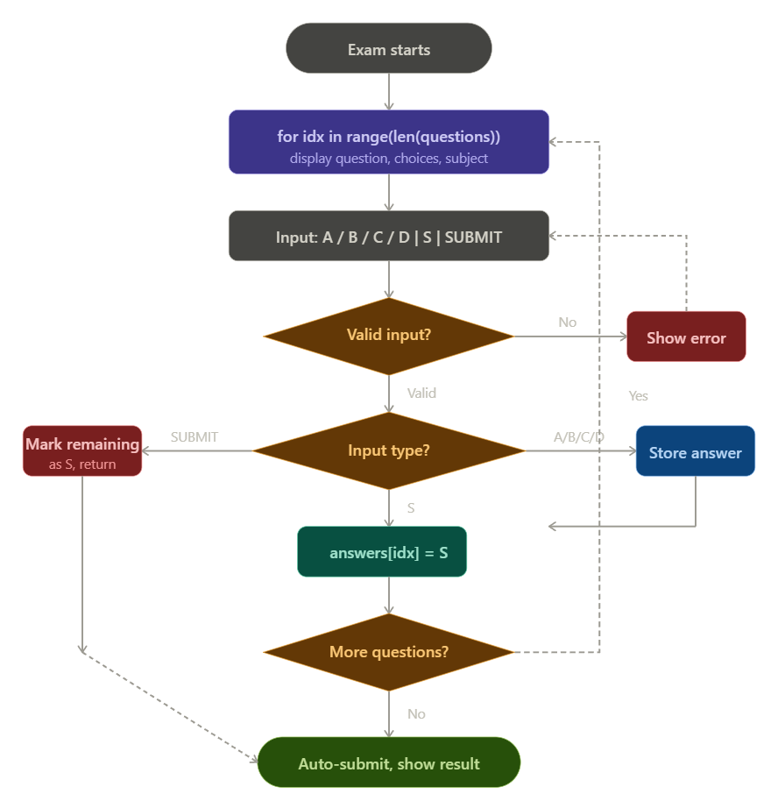

Figure 7 — conduct_exam flowchart: the for loop, inner input-validation while loop, A/B/C/D answer path, skip path, early SUBMIT path, and auto-submit on completion

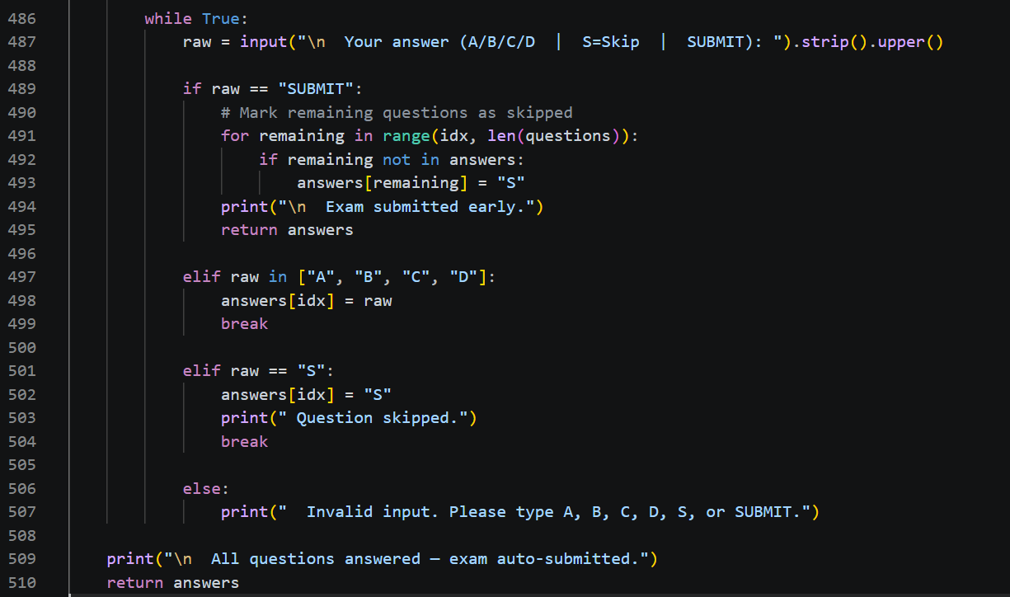

Figure 8 — The input-validation loop inside conduct_exam(): four branches handling SUBMIT, valid answer, skip, and invalid input

5.4 Scoring and Grading

The calculate_score function is a pure computation: given the answers dictionary it iterates every entry, increments the correct, wrong, or skipped counters, and returns a four-element tuple of (score, correct, wrong, skipped). The score is computed as (correct * 4) + (wrong * -1), a straightforward application of the specified marking scheme. The function knows nothing about student names, roll numbers, or dates; it only transforms one data structure into a numerical result.
Grade classification is equally simple. The get_grade function receives a percentage and returns one of four strings — EXCELLENT, GOOD, AVERAGE, or BELOW AVERAGE — using a cascade of if-elif-else conditions keyed to the boundaries specified in the project brief: 80 percent and above, 65 to 79, 50 to 64, and below 50 respectively.

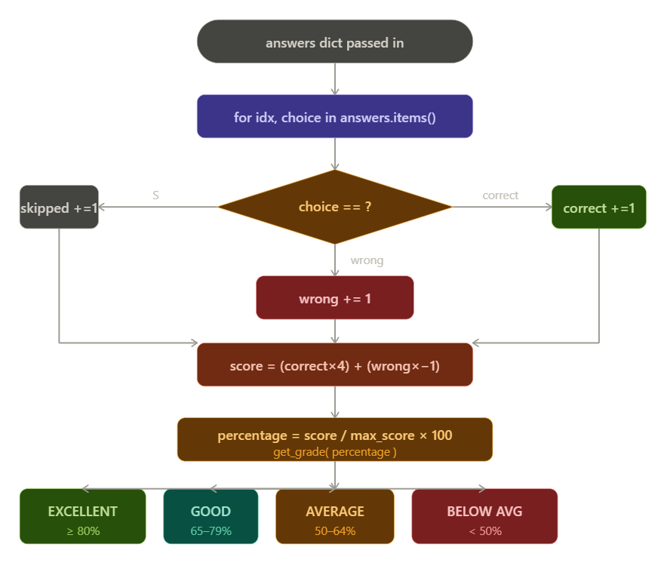
Figure 9 — Scoring flowchart: answers dict iteration, three-way branch (correct/wrong/skipped), score formula, and four grade classifications

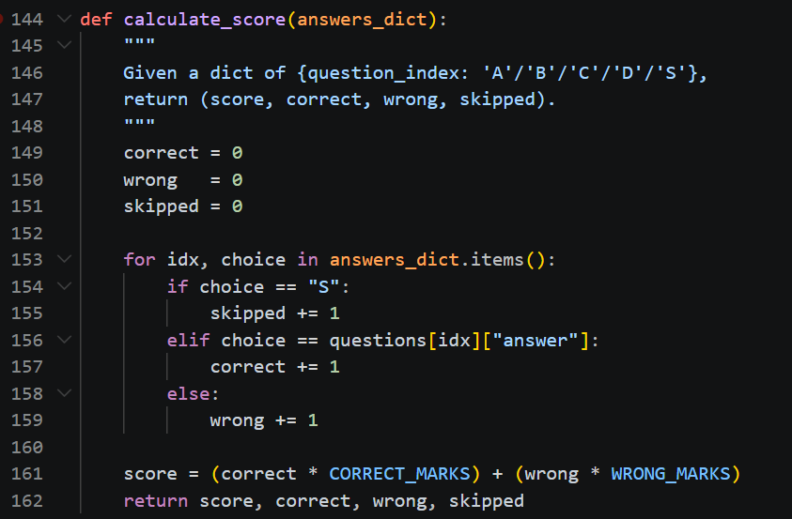
Figure 10 — calculate_score() applies the marking formula and returns a four-value tuple;
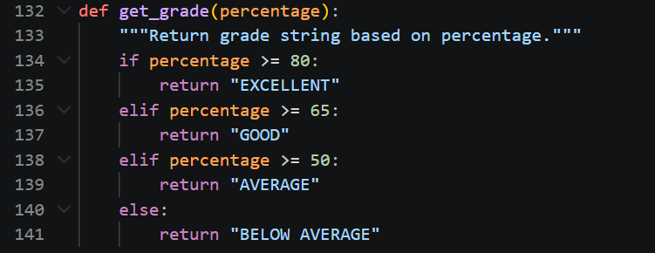
get_grade() maps a percentage to one of four grade strings

5.5 Result Display and Review

The show_student_result function serves two purposes simultaneously: it assembles the result record and appends it to all_results, and it prints the result to the console. The result record is constructed first, then appended, then printed — this ordering guarantees that even if the print logic were to raise an exception, the record would already be saved. The answer review iterates the questions list a second time, using answers_dict.get(idx, 'S') to safely retrieve each response with S as the default for any index not present in the dictionary.

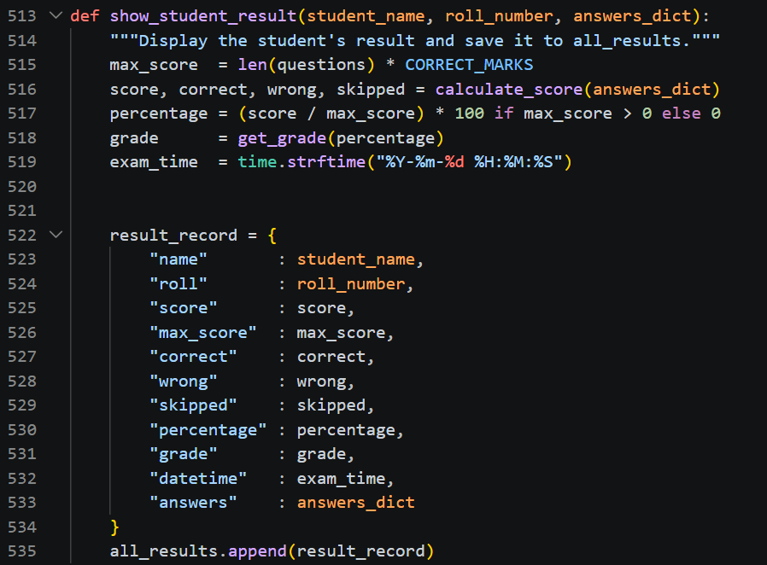

On the admin side, admin_view_detailed_result allows drilling into any historical attempt by selecting its number from a list. It retrieves the corresponding result record from all_results and uses the embedded answers dictionary to produce the same per-question verdict display, giving the admin full visibility into exactly how each student performed on each individual question.
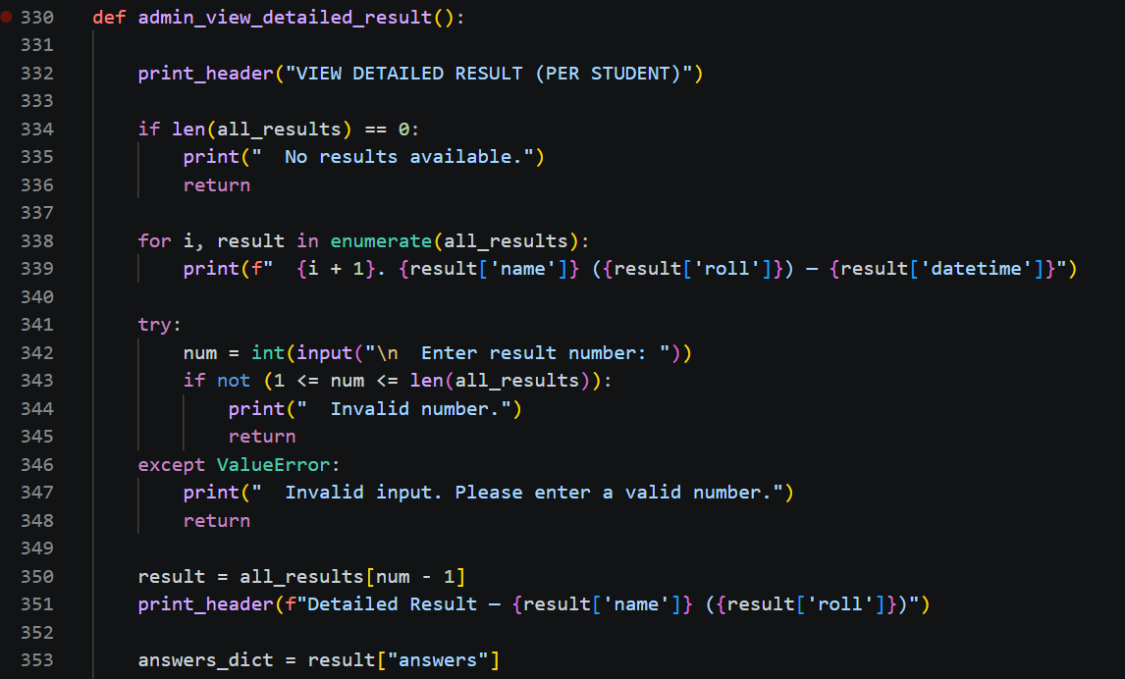

5.6 Class-Level Analytics

The admin_class_statistics function derives its metrics from the all_results list using Python's built-in max, min, sum, and len functions. The pass rate is computed by summing a generator expression that yields 1 for every result whose percentage is at or above fifty. The grade distribution is accumulated into a dictionary using the get method with a default of zero, the same pattern used in the question bank's subject-count function admin_question_statistics.

6. PYTHON CONCEPTS IN PRACTICE

One of the explicit requirements of this activity is to demonstrate the Python concepts taught during CMPE-112L. The following discussion maps those concepts to the code, explaining not just where each appears but why it was the natural choice for that part of the problem.

6.1 Variables, Constants, and Data Types

The module opens with a block of constants — CORRECT_MARKS, WRONG_MARKS, SKIP_MARKS, MIN_QUESTIONS, MAX_ATTEMPTS, and the two pairs of credentials. By convention, names in all-capitals signal values that are fixed for the application's lifetime. This practice is important not merely as style but as a safeguard: when the marking scheme needs to change, there is exactly one place in the code to update. The alternative — embedding the integer 4 directly into the score formula — creates silent inconsistency the moment any other part of the code also needs to know the per-correct-answer award.
Throughout the application, string variables carry user-facing text and identifiers, integer variables carry counts and scores, and boolean return values communicate login success or failure between functions. The consistent use of appropriate types, rather than representing everything as a string, keeps the arithmetic clean and the conditional logic unambiguous.

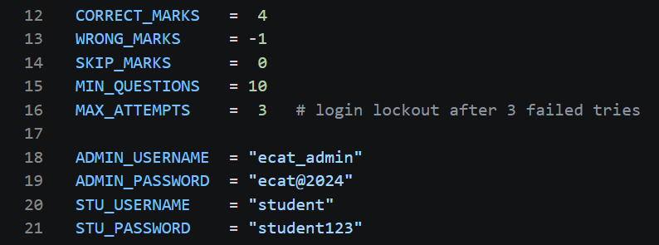
Figure 11 — Module-level constants: marking values, login attempt ceiling, and hardcoded credentials, all defined as named constants at the top of the file

6.2 Conditional Logic

Conditional statements appear in every function. The login functions use if to test credential equality and elif-else to count failures. The menu dispatchers use long elif chains to map a user's choice to the appropriate function. The grade classifier uses an ordered if-elif-else ladder that must be read from the top: the 80-percent boundary is checked first so that a score of 85 is correctly identified as EXCELLENT rather than falling through to GOOD or AVERAGE.
The answer-review logic presents a slightly more complex conditional pattern: a three-way branch that distinguishes skipped answers (the sentinel S) from correct answers (student letter equals question answer) from wrong answers (everything else). This pattern appears in both show_student_result and admin_view_detailed_result, reflecting the fact that the same three-state outcome must be presented in two different contexts.

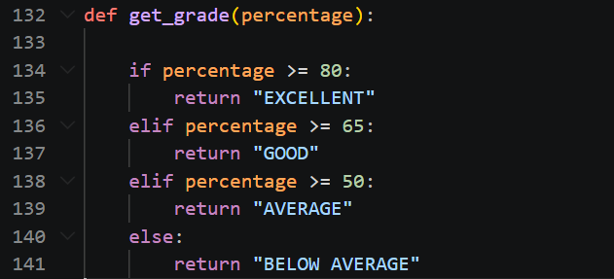
Figure 12 — The get_grade() if-elif-else cascade: boundary checks are ordered from highest to lowest so each band is tested exactly once

6.3 Loops

The while loop is the workhorse of the interactive portions of the application. Every menu, every login prompt, and every answer-input cycle is driven by a while loop with an explicit exit condition. The login loops are bounded by MAX_ATTEMPTS; the menu loops run until the user selects the logout or exit option; the answer loop runs until a valid token is received or the student types SUBMIT.
The for loop handles all sequential traversal of data. Walking the questions list during an exam, iterating results for display, and accumulating subject counts from the question bank are all for loop operations. In the exam specifically, range(len(questions)) is used rather than direct iteration over the list because the index is needed as a key — a reminder that the choice between index-based and value-based iteration is a deliberate design decision, not an arbitrary one.

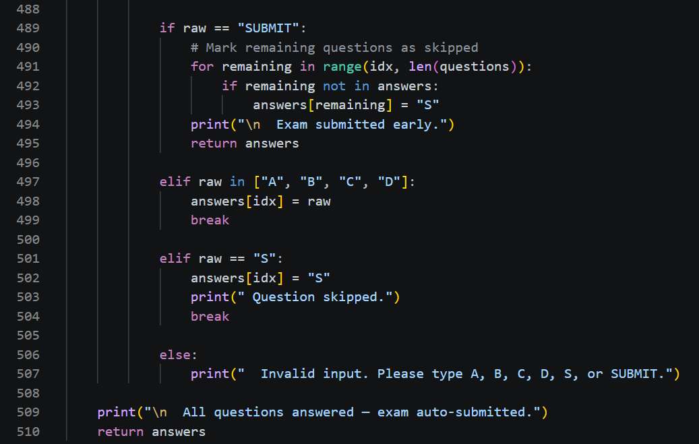
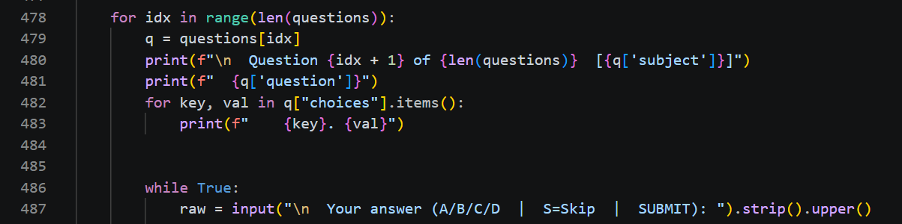

Figure 13 — The for loop driving the exam (with range/len for indexed access) and the inner while True loop that enforces valid input on each question

6.4 Functions

The application defines seventeen functions, each representing a single cohesive operation. Helper functions such as print_header, print_line, pause, get_grade, and calculate_score are designed to be called from multiple sites; feature functions such as admin_add_question and conduct_exam are called from exactly one menu handler. This distinction reflects the single-responsibility principle applied at the function level.
Return values are used purposefully. Login functions return status flags and captured data. calculate_score returns a tuple so that four related values travel together. get_grade returns a string. conduct_exam returns the completed answers dictionary. Functions that perform display or mutation — the admin feature functions, show_student_result — return nothing, relying instead on side effects on the global data structures or the console.

6.5 Lists and Dictionaries

The questions and all_results variables are lists of dictionaries — the most natural Python representation of a homogeneous collection of structured records. A list preserves insertion order and supports O(1) appends, making it ideal for the question bank and the results register. Dictionary keys provide named access to each field, eliminating the positional indexing that would make a list-of-lists opaque.
The answers dictionary uses integer indices as keys, matching the loop variable used during the exam. The .get(idx, 'S') pattern provides a safe default that treats an unvisited question as skipped, which is exactly the correct semantic for a student who submitted before reaching that question. The nested choices dictionary within each question record allows the exam display code to iterate over the four options in a single for loop without needing to know the specific letters in advance.

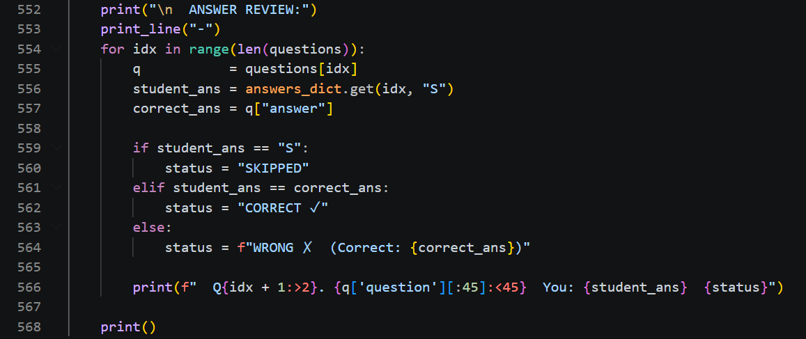
Figure 14 — The .get(idx, 'S') pattern: safely fetches each stored answer, defaulting to 'S' for any question the student did not reach

6.6 String Methods and the time Module

String methods are used throughout the input-handling code. The .strip() method removes leading and trailing whitespace before any comparison, preventing the common user mistake of an accidental space invalidating an otherwise correct entry. The .upper() method normalises letter-choice input, so a student who types a lowercase b is not penalised for a typographical convention.
The time module is imported for two specific purposes. The time.sleep function introduces a brief pause after a successful login, giving the user a moment to register the confirmation message before the next screen appears — a small but meaningful improvement to the console experience. The time.strftime function records the exact date and time of exam submission in each result record, providing an auditable timestamp that the admin can inspect in both the summary table and the detailed result view.

7. TESTING AND VERIFICATION

Because the application is console-based and holds all state in memory, verification is a matter of running through a series of scenarios and confirming that the output matches the specification. The following scenarios cover the principal pathways through the code.

7.1 Login Lockout

Entering incorrect credentials three times on either portal results in the message Account locked — too many failed attempts and an immediate return to the main menu. No further input is accepted, confirming that the MAX_ATTEMPTS ceiling is enforced. A single correct credential on any attempt within the first three cancels the lockout and grants access normally.

7.2 Marking Scheme Verification

A controlled exam in which all twelve questions were answered correctly produces a score of 48, which is twelve multiplied by four, representing the maximum possible result. An exam in which all twelve questions were answered incorrectly produces a score of negative twelve, confirming that wrong answers subtract one mark each. An exam in which all questions were skipped produces a score of zero, and an exam submitted immediately via SUBMIT with no questions answered also produces a zero — both confirming that the skip penalty is correctly implemented as nil.
A mixed exam — some correct, some wrong, some skipped — was verified against the formula (correct x 4) + (wrong x -1) manually before running the code. In every case the application's computed score matched the manual calculation, confirming that the calculate_score function is correct.

7.3 Admin Operations

A new question was added via the admin portal and immediately verified to appear in the View All Questions display and to be presented to a student logging in for an exam in the same session. The question was then deleted and verified to disappear from both displays. The question count in the statistics panel updated correctly in both directions.
The class result statistics were verified by running three student exams with known scores, then checking that the highest, lowest, and average values reported by the admin panel matched the manually computed figures. The pass and fail counts were similarly confirmed against the fifty-percent threshold.

8. LIMITATIONS AND FUTURE DIRECTIONS

The application satisfies every requirement of the project brief, but several constraints arise naturally from the decision to use only the concepts taught in a first-semester course. Acknowledging these constraints is itself a form of engineering awareness — understanding where a system's current design ends and where a next version would begin.

8.1 Persistence

All data is lost when the program exits. Questions added or deleted during a session are not written to disk, and results accumulated during one run are not available in the next. A natural extension would be to persist both the question bank and the results register to JSON files using Python's json module, reading them at startup and writing them after every modification. This would require no change to the in-memory data structures — the lists and dictionaries would remain identical — only the addition of load and save functions around the existing logic.

8.2 Authentication

The current authentication model uses a single shared student credential, meaning that any student who knows the password can log in as any student by typing any name and roll number. A more robust design would maintain a per-student credential store, keyed by roll number, with each student's name and password stored in a dictionary or a simple CSV file. The three-attempt lockout logic would remain unchanged; only the credential lookup would differ.

8.3 Randomisation and Time Limits

The questions are always presented in the order they appear in the list. Importing Python's random module and calling random.shuffle on a copy of the list before the exam begins would prevent students from memorising the order across attempts. A time limit per question or per exam could be implemented using Python's time module, presenting a non-trivial design challenge in a console environment but one well within reach of a second-semester student.

8.4 Graphical Interface

The console interface is functional and readable, but a graphical user interface built with tkinter — Python's standard GUI library — would significantly improve the examination experience, particularly for students unfamiliar with command-line environments. Radio buttons for answer selection, a countdown timer display, and colour-coded result panels are all achievable with relatively modest additional code once the underlying logic — which this application already provides in a well-structured form — is in place.

9. OUTPUT / RESULTS

This section presents the actual console outputs generated by the ECAT Exam Application during a complete test run. The screenshots are organised in the order a user encounters them — from the initial launch screen through Admin Portal operations and a full Student Portal examination session — so that the reader can trace the program’s execution path alongside the code discussed in earlier sections. Each screenshot is accompanied by a brief caption explaining what the output demonstrates and which part of the implementation produced it.

9.1 Program Launch — Main Portal Selection

When the program is executed, the main() function displays the application title, the institution name, and three numbered options: Admin Portal, Student Portal, and Exit. This is the top-level dispatcher produced by the outermost while loop. The formatted border lines are drawn by the line() helper function.

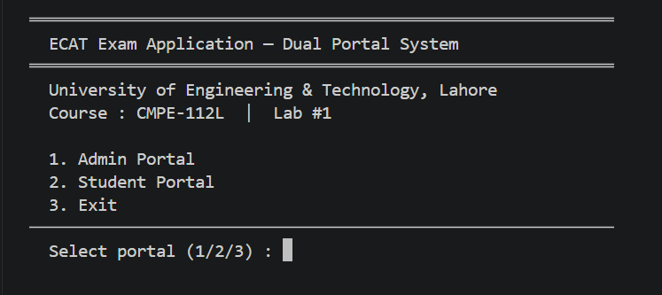

9.2 Admin Portal — Login and Lockout
Selecting option 1 invokes admin_portal(), which immediately calls login(). The screenshot below shows two scenarios side by side: a failed login attempt displaying the remaining-attempts warning, and a successful login granting access. Entering three consecutive wrong credentials triggers the “Account locked” message and returns the user to the main menu without displaying the admin menu.

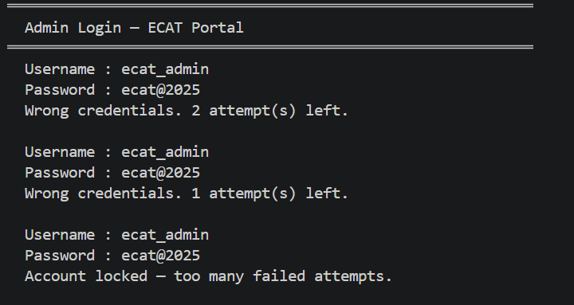
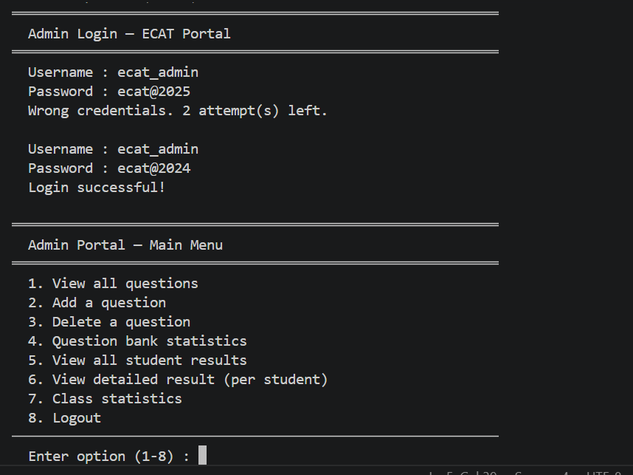

9.3 Admin Portal — Main Menu
After successful authentication, the admin_portal() function displays an eight-option menu. Each option maps to a dedicated function, reflecting the single-responsibility design described in Section 5. The menu persists in a while loop until option 8 (Logout) is selected.

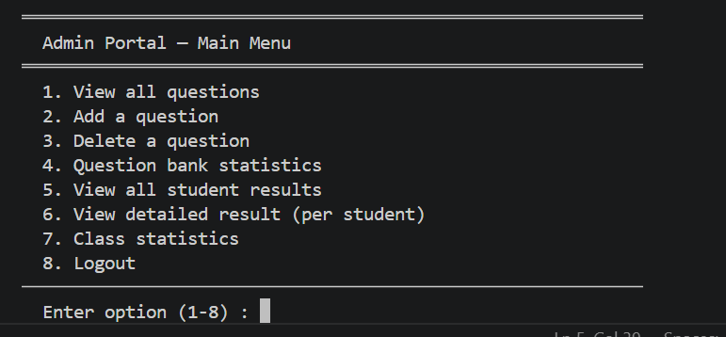

9.4 Admin — View All Questions
Option 1 calls admin_view_questions(), which iterates the questions list with enumerate and prints each question’s subject, text, and four choices. The correct answer is flagged with a ✓ tick mark beside the appropriate option, making it immediately legible without requiring the admin to decode letter codes manually.

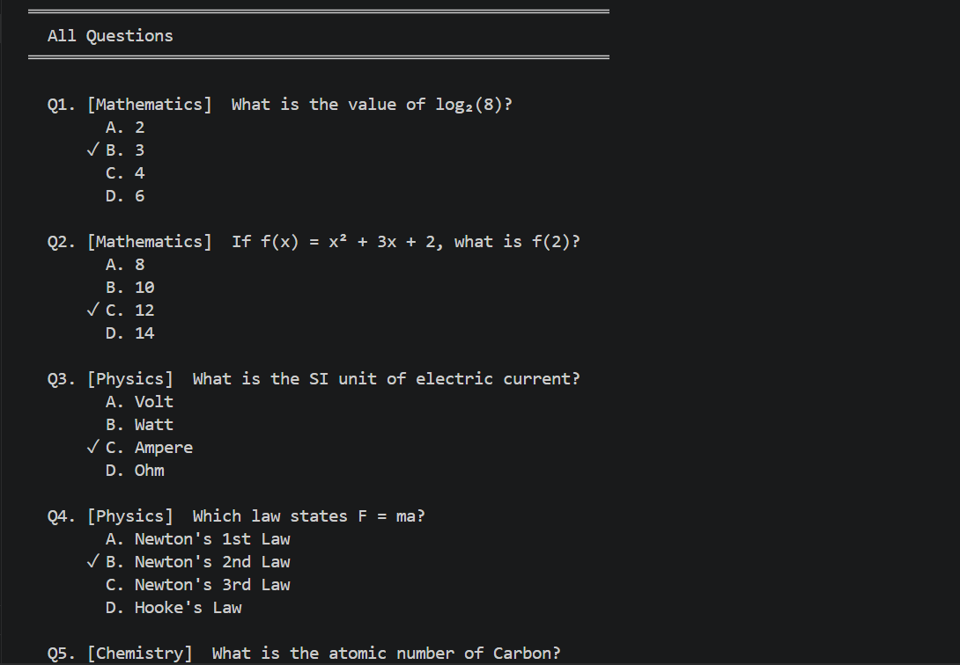
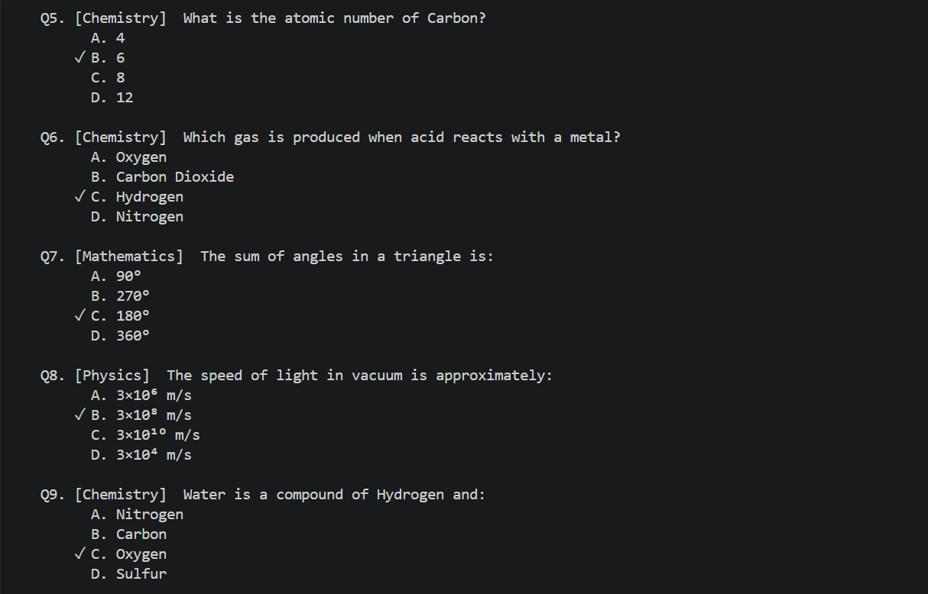

9.5 Admin — Add and Delete a Question
Option 2 (Add) walks the admin through a guided input sequence — subject, question text, four choices, and the correct letter — then confirms the addition with the updated total question count. Option 3 (Delete) lists all questions by number, accepts a selection, and confirms deletion by echoing the removed question’s text. Both changes take effect immediately for any subsequent exam session.
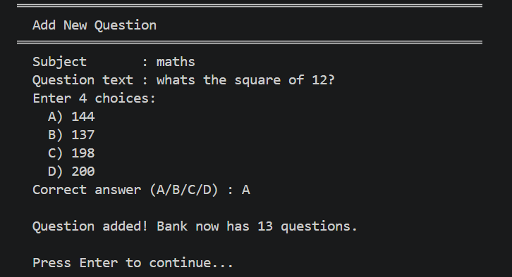
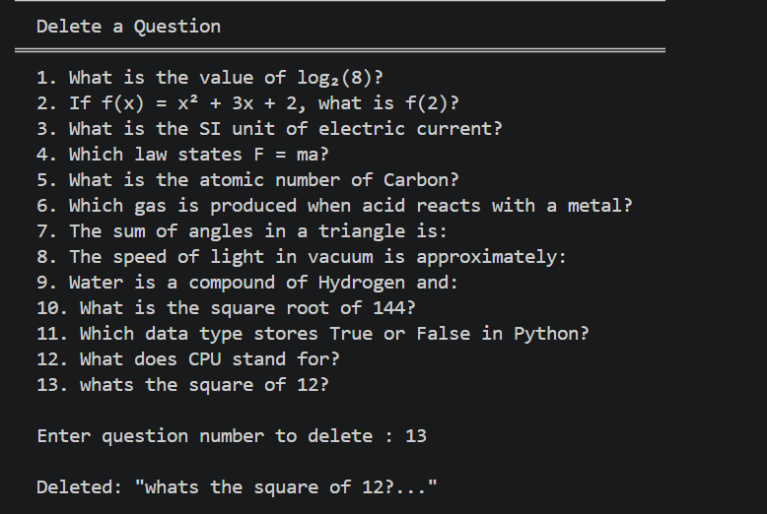

9.6 Admin — Question Bank Statistics
Option 4 calls admin_question_stats(), which builds a subject-count dictionary using the .get() pattern and prints a formatted two-column table showing how many questions belong to each discipline. The total question count is displayed above the breakdown.

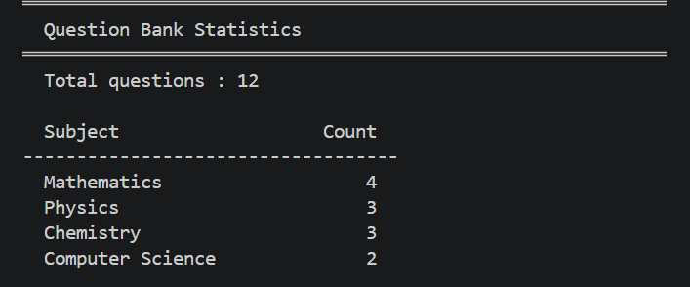

9.7 Student Portal — Login, Profile Entry, and Exam Rules
Selecting option 2 from the main menu invokes student_portal(). After credential verification, the system prompts for the student’s full name and roll number — both of which are embedded in every result record. Option 2 of the student menu (View Exam Rules) displays the complete marking scheme (+4 / −1 / 0) and navigation instructions before any exam begins.
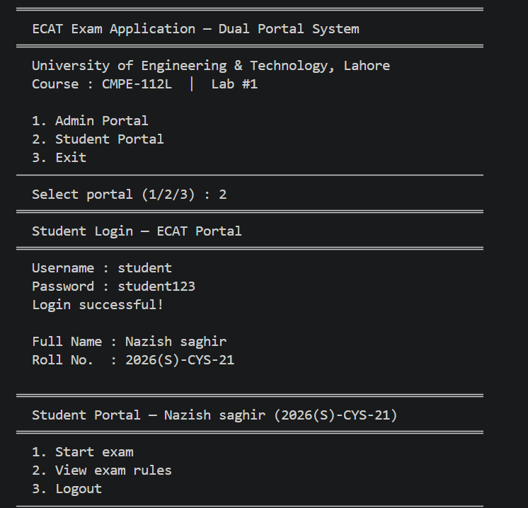

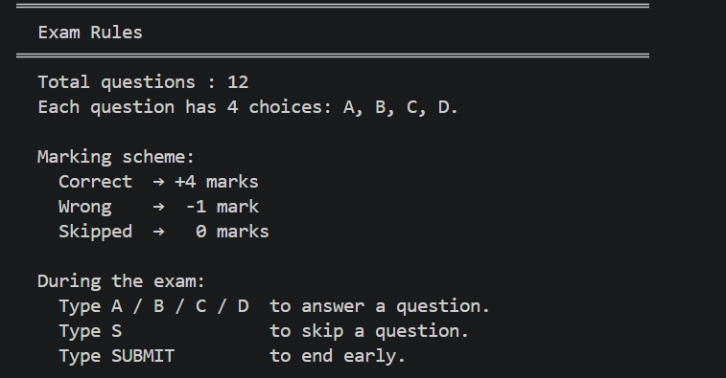

9.8 Student Portal — Exam Session in Progress
The conduct_exam() function drives the live exam. Each question is displayed one at a time with its subject tag, question text, and four labelled choices. The inner while True loop enforces valid input — only A, B, C, D, S (skip), or SUBMIT are accepted. The screenshot below captures a mid-exam question alongside the input prompt, demonstrating the subject label and choice layout produced by the for loop.
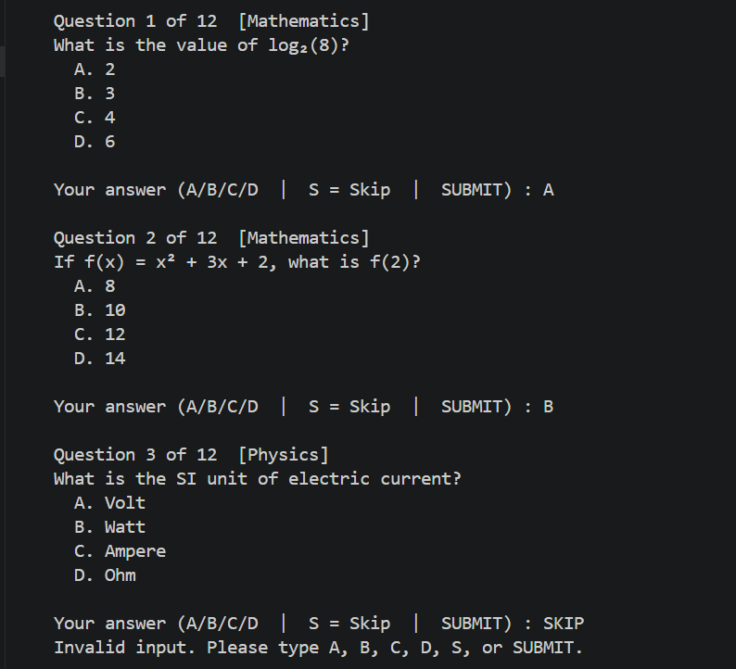

9.9 Student Portal — Exam Result and Answer Review
Immediately after the final question (or an early SUBMIT), show_result() calculates the score using the +4 / −1 / 0 formula, determines the grade via get_grade(), and appends the full record to all_results. The result screen displays the student’s name, roll number, correct/wrong/skipped counts, raw score, percentage, and grade. It is followed by a per-question answer review in which every response is labelled Correct ✓, Wrong ✗ (with the correct answer shown), or Skipped.
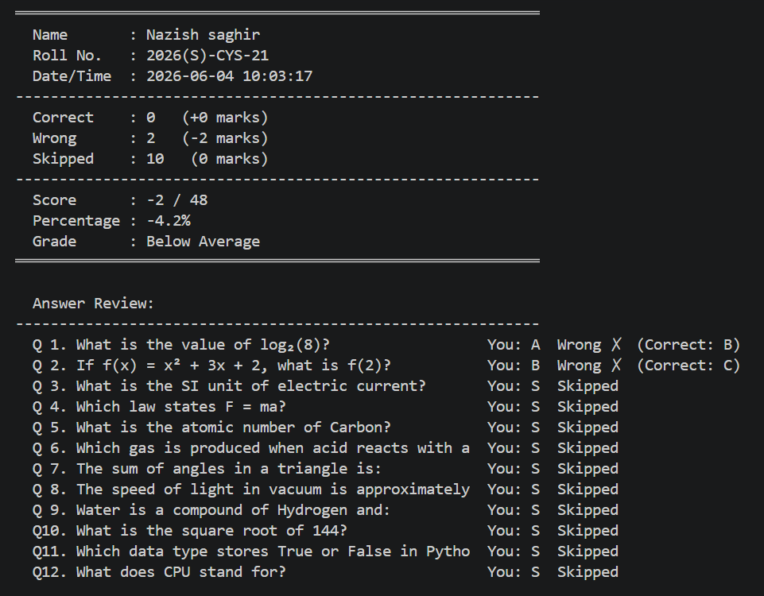

9.10 Admin — All Student Results and Detailed Drill-Down
Admin option 5 calls admin_view_all_results(), printing a tabular summary of every attempt stored in all_results — name, roll number, score, percentage, grade, and timestamp. Option 6 (Detailed Result) lets the admin select any row and view the full question-by-question breakdown for that student, reconstructed from the embedded answers dictionary in the result record. To capture these screenshots, complete at least two or three student exam sessions first so the table has meaningful data.

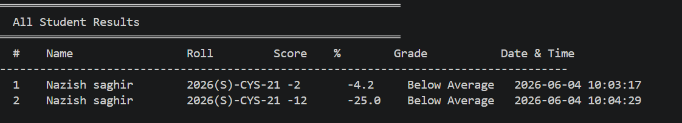

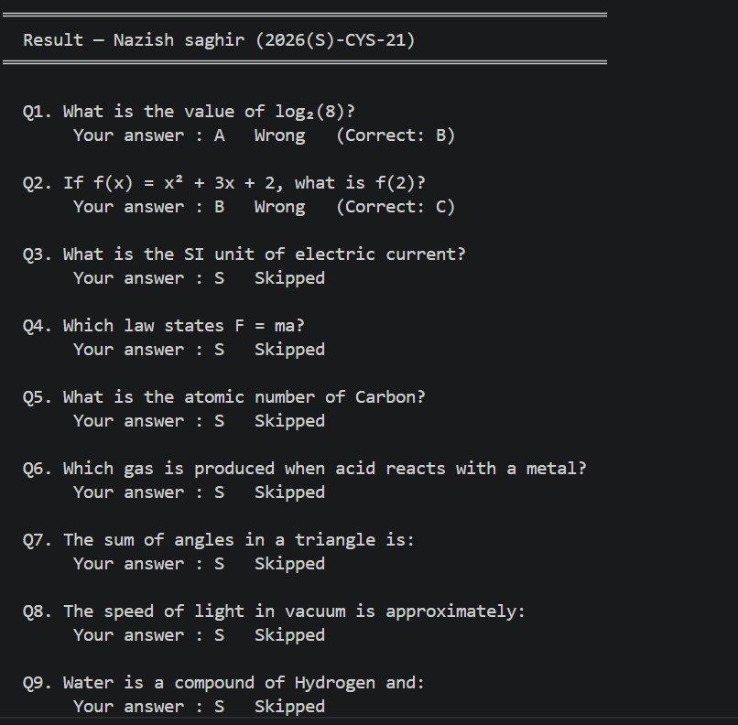

DETAILED OVERVIEW OF RESULT

9.11 Admin — Class Statistics
Admin option 7 calls admin_class_stats(), which derives aggregate metrics from all_results using Python’s built-in max(), min(), sum(), and len() functions. The output shows the total number of attempts, the highest and lowest scores, the class average, the pass and fail counts (threshold: 50%), and a grade distribution breakdown listing how many students fall into each of the four grade bands.

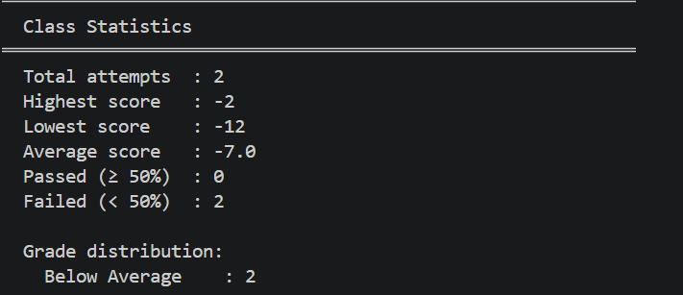

9. CONCLUSION

The ECAT Exam Application demonstrates that a first-semester programming student, armed with variables, loops, conditionals, functions, lists, and dictionaries, can produce a system of genuine practical utility. The application is not a toy: it enforces login security, manages a dynamic question bank, administers a structured examination with negative marking, and generates both student-facing and administrator-facing reports — all within a single, coherent Python program of manageable size.
The design choices documented in this report — pure functions with single responsibilities, module-level data structures, explicit constants, and a layered menu architecture — reflect an effort to write code that communicates its intent as clearly as it executes its logic. The seventeen functions are not merely procedural chunks; they represent a considered decomposition of a real problem into parts that can be understood, tested, and extended independently.
Perhaps most importantly, the project demonstrates that the gap between learning to program and building something meaningful is not as wide as it might appear. The concepts covered in CMPE-112L are not preliminaries to real programming; they are the foundation on which real programs are built. This application, functional and deployed from day one, is the evidence.

Nazish Saghir | 2026(S)-CYS-21 | CMPE-112L | UET Lahore | Sir Hafiz Muhammad Mubashar

